**Registering the domain name process**

To register a domain name, you will need to do the following steps: (Website.com)

Firstly, choose a domain name.

Then, there’s some information you need to provide the registrar, and they are: (Website.com)

1. The chosen domain name.
2. Name of the person that requested the registration, his email, phone number, the physical address, the administrative and billing contacts.
3. The registration term for the domain name registration
4. Payment information such as: billing info, card number, CVV.

After submitting this information: (Website.com)

1. The registry will start the domain name registration process for your request.
2. The registrar will send your chosen name request and then contacting the technical information of your domain name to the registry.
3. The registry files the contact information for the Whois which is lookup and IP address.
4. The registry will store the domain name zone files in the master servers
5. The master server will contact other servers that is connected to the internet and tells where the website is stored

And then, when all information is updated, the domain will be considered and registered as ready-to-use. (Website.com)

**References:**

# Bibliography

**Registering a Domain Name** [Online] / auth. Website.com // Website.com Learning center. - https://www.website.com/beginnerguide/registeringdomain/4/9/domain-name-registration-process.ws.

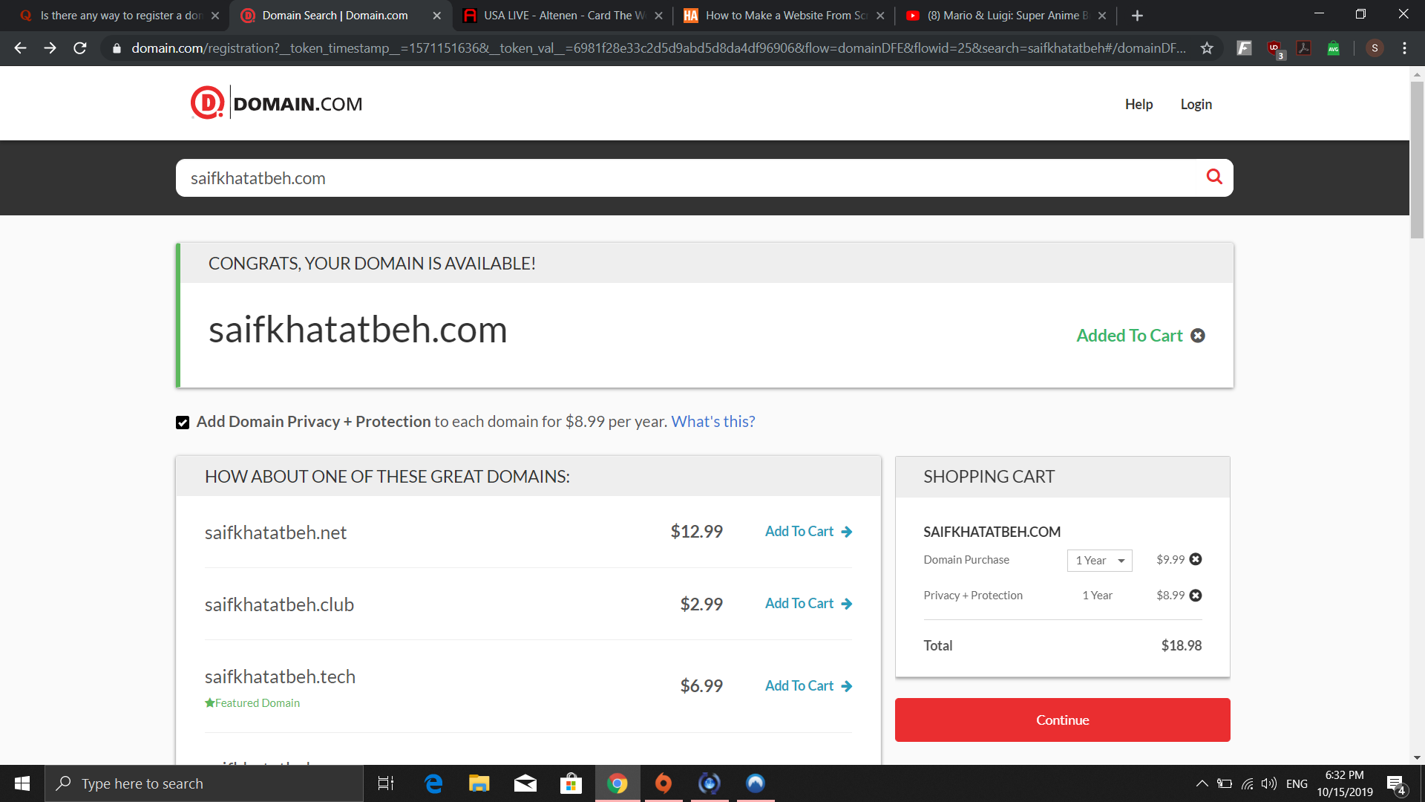

There are many ways to register a domain name, the simplest one is buying a custom domain name from a third party website, in this case we used Domain.com.